Architecture Design

Data Visualization of Bird Strikes between 2000 – 2011

Aakash Pal

**Contents**

1. Introduction ………………………………………………………………………..….. 3

1.1 What is Architecture Design Document? ……………………………………….... 3

1.2 Scope ………………………………………………………………………………… 3

2. Architecture …………………………………………………………………………... 4

2.1 Components of Power BI ………………………………………………………..… 4

2.1.1 Power Query …………………………………………………………………..…. 4

2.1.2 Power Pivot ………………………………………………………………….…… 4

2.1.3 Power View ……………………………………………………………….……… 4

2.1.4 Power Map ………………………………………………………………..……… 5

2.1.5 Power BI Desktop ……………………………………………………….………. 5

2.1.6 Power Q&A …………………………………………………………….………… 5

3. Deployment ………………………………………………………………………….. 6

3.1 File Share …………………………………………………………………………... 6

3.2 SharePoint …………………………………………………………………………. 7

3.3 Third Party Integration …………………………………………………………….. 7

**1. Introduction**

**1.1 What is Architecture Design Document?**

Any software needs the architectural design to represents the design of software. IEEE defines architectural design as “the process of defining a collection of hardware and software components and their interfaces to establish the framework for the development of a computer system.” The software that is built for computer-based systems can exhibit one of these many architectures.

Each style will describe a system category that consists of:

• A set of components (e.g.: a database, computational modules) that will perform a function required by the system.

• The set of connectors will help in coordination, communication, and cooperation between the components.

• Conditions that how components can be integrated to form the system.

• Semantic models that help the designer to understand the overall properties of the system.

**1.2 Scope**

Architecture Design Document (ADD) is an architecture design process that follows a step-by-step refinement process. The process can be used for designing data structures, required software architecture, source code and ultimately, performance algorithms. Overall, the design principles may be defined during requirement analysis and then refined during architectural design work.

**2. Architecture**

Power BI architecture is a service built on top of Azure. There are multiple data sources that Power BI can connect to. Power BI Desktop allows you to create reports and data visualizations on the dataset. Power BI gateway is connected to on-premise data sources to get continuous data for reporting and analytics. Power BI services refer to the cloud services that are used to publish Power BI reports and data visualizations. Using Power BI mobile apps, you can stay connected to their data from anywhere. Power BI apps are available for Windows, iOS, and Android platforms.

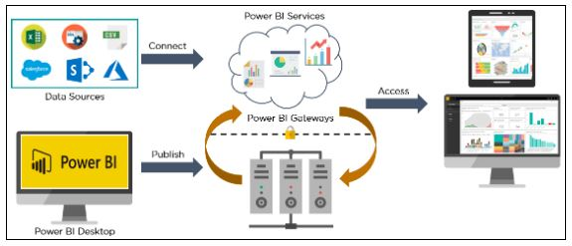

**2.1 Components of Power BI**

1. **Power Query**: Power Query is the data transformation and mash up the engine. It enables you to discover, connect, combine, and refine data sources to meet your analysis need. It can be downloaded as an add-in for Excel or can be used as part of the Power BI Desktop.

2. **Power Pivot:** Power Pivot is a data modeling technique that lets you create data models, establish relationships, and create calculations. It uses Data Analysis Expression (DAX) language to model simple and complex data.

3. **Power View:** Power View is a technology that is available in Excel, SharePoint, SQL Server, and Power BI. It lets you create interactive charts, graphs, maps, and other visuals that bring your data to life. It can connect to data sources and filter data for each data visualization element or the entire report.

4. **Power Map:** Microsoft's Power Map for Excel and Power BI is a 3-D data visualization tool that lets you map your data and plot more than a million rows of data visually on Bing maps in 3-D format from an Excel table or Data Model in Excel. Power Map works with Bing maps to get the best visualization based on latitude, longitude, or country, state, city, and street address information.

5. **Power BI Desktop**: Power BI Desktop is a development tool for Power Query, Power Pivot, and Power View. With Power BI Desktop, you have everything under the same solution, and it is easier to develop BI and data analysis experience.

6. **Power Q&A:** The Q&A feature in Power BI lets you explore your data in your own words. It is the fastest way to get an answer from your data using natural language. An example could be what was the total sales last year? Once you've built your data model and deployed that into the Power BI website, then you can ask questions and get answers quickly.

**3. Deployment**

Power BI can be deployed on premise three different options. Kindly refer below diagram.

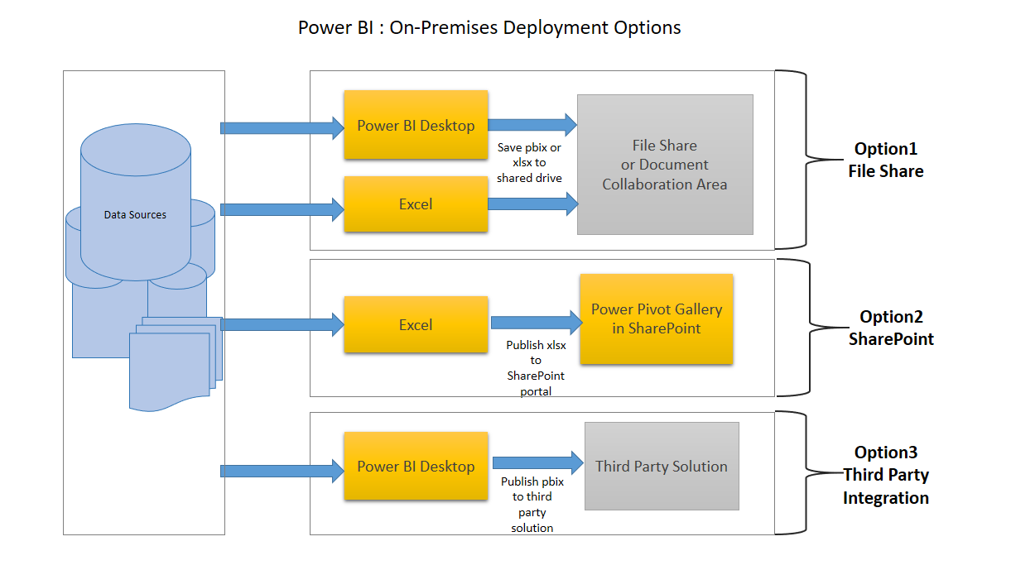

**Option 1: File Share**

The first on-premises option involves usage of a file share:

* Data preparation and report creation is done in client tools: Power BI Desktop and/or Excel.
* The completed Power BI Desktop and/or Excel file is published to a file share or a document collaboration area / repository.
* To view the reports, Excel or Power BI desktop has to be installed on the viewer’s machine.

**Option 2: SharePoint**

The second on-premises option involves a specialized document library in SharePoint called the Power Pivot Gallery. Due to my limited knowledge, I am not going in details of this option:

* Data preparation and report creation occurs in Excel.
* The completed Excel file is published to SharePoint within a Power Pivot Gallery.

**Option 3: Third Party Integration**

The third on-premises option involves a third party which integrates with Power BI.

* Data preparation and report creation occurs in Power BI Desktop.
* The completed Power BI Desktop file is published to the third party server.